

FICHA CLÍNICA DA MULHER

Data: ____/____/_______ Prontuário: _____________________________
Nome: _________________________________________________________ Profissão: __________________
Endereço: _________________________________________________________________________________
Cidade: ________________________ UF: _______ CEP: _________________ Telefone: _________________
Idade: ________ < 15 15 - 35 > 35
Escolaridade Nenhuma 1º Grau 2º Grau Superior
Estado Civil/União Casada Solteira(sem união estável) Solteira (com união estável)
Outra: _______________________________________________________________
Cor/Raça Branca Negra Parda Indígena Asiática
Natural: _______________________________

Queixa:___________________________________________________________________________________________________________________________________________________________________________________________________________________________________________________________________________

HPMA:___________________________________________________________________________________________________________________________________________________________________________________________________________________________________________________________________________

ISDA: Cardiovascular: _______________________________________________________________________
Gastrointestinal: _______________________________________________________________________
Urinário: _____________________________________________________________________________
Respiratório: __________________________________________________________________________

AF: Cardiovascular: __________________________ Endócrino/Metabólico___________________________
Câncer: ________________________________ Infecção: _____________________________________
Outros: ______________________________________________________________________________

AP: Clínicos: _____________________________________________________________________________
Cirurgias: ____________________________________________________________________________
Tabagismo: ______________________________ Etilismo: _____________________________________
Medicações: __________________________________________________________________________
Outros: ______________________________________________________________________________

AM: Menarca: ____________________ ciclos: _________________________ DUM: ____________________
Dismenorréia: ________________________________________________ TPM: ____________________
Menopausa: natural ( ) cirúrgica ( )

AS: 1ºCoito: ____________________________________ Nº parceiros: _______________________________
Libido: _____________________________________ Orgasmos: ________________________________
Anticoncepção: ________________________________________________________________________

AG: Corrimento: _________________________________ Cirurgia: __________________________________
Cauterização: _________________________________________________________________________

AO: G: __________ P: __________ A: __________ PNL: __________ PC: ___________ PF: _____________
1º.parto: __________________ último: _____________________ Peso RN (maior): _________________
Amamentação: ________________________________________________________________________
Puerpério: ____________________________________________________________________________

Exame
Peso: _______________ Alt: ___________________ PA: __________________ IMC: ______________________
Ap. cardiovascular: ___________________________ Ap. respiratório: __________________________________
MMII: ______________________________________ Outros: _________________________________________
Abdome: ___________________________________________________________________________________
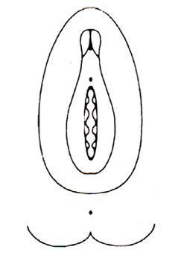

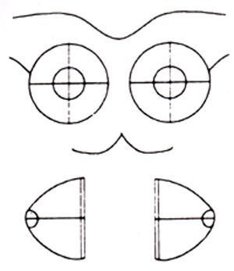
MAMAS

Insp. Estática __________________________________
_____________________________________________

Insp. Dinâmica:_________________________________
_____________________________________________

Palpação: _____________________________________
_____________________________________________

Expressão: ____________________________________

Axilas: _______________________________________
_____________________________________________

OGI: TOQUE

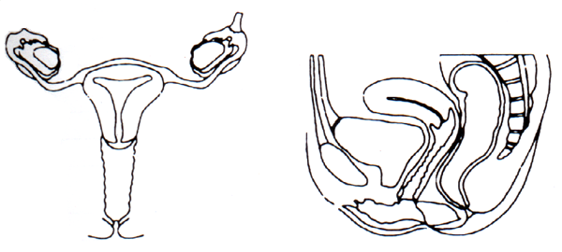

Vagina: _______________________________________
_____________________________________________

Colo: ________________________________________
_____________________________________________

Útero: ________________________________________
_____________________________________________

AN. D:________________________________________
NA. E:________________________________________

Paramétrios: __________________________________

Reto: ________________________________________

OGE

Pilificação: __________________________________
Lábios: ____________________________________
Clitóris: ____________________________________
Uretra: ____________________________________
Gl. Bartholin: _______________________________
Hímen: ____________________________________
Procidência PVA: ____________________________
PVP: ____________________________
Períneo: ___________________________________
Perda urina: ________________________________

ESPECULAR

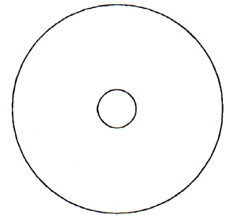

Vagina: ___________________________________
__________________________________________

Colo: ______________________________________
__________________________________________

Cont. vaginal: _______________________________
__________________________________________

Outros Exames
Tração do colo: ______________________________________Histerometria: ______________________
Diagnóstico Clínico: _________________________________________________________________________
Exames solicitados: _________________________________________________________________________


Conduta: __________________________________________________________________________________

